Technical Design Document

Robotics Process Automation

Return From Leave

University of California
Oracle Cloud Financial - Finance

Authors: Chris Palmer/ Ari Widjaja
Creation Date: March 20, 2025
Updated:
Document Ref: 001
Version: 1.5
Approvals:

Document Control
Change Record
Date | Author | Version | Change Reference
03/20/2025 | Chris Palmer | 1.0 | Initial Draft
 |  | 1.1 | FDD updates based on internal review
10/22/2025 | Ari Widjaja | 1.2 | FDD updates based on final PDD v1.7. Added Proposed Solution section
02/15/2026 | Ari Widjaja | 1.3 | FDD update based on UCP-184825. Added Technical Change Note section
04/13/2026 | Ari Widjaja | 1.4 | FDD updates based on CR UCP-188100. Updated Technical Change Note section
04/15/2026 | Ari Widjaja | 1.5 | Added changes per UCP-188507 on Technical Change Note section

Contributors
Name | Position | Organization | Version | Date
Brandi Festa | Controller | UCPath | 1.0 | 03/04/2025
Daniel Teeter | Finance Benefits Billing Supervisor | UCPath | 1.0 | 03/04/2025
Laura Doyle | Finance Benefits Billing Analyst | UCPath | 1.0 | 03/04/2025
Contents
Document Control ii
Topical Essay 4

To update the table of contents, put the cursor anywhere in the table and press [F9]. To change the number of levels displayed, select the menu option Insert->Index and Tables, make sure the Table of Contents tab is active, and change the Number of Levels to a new value.

Topical Essay
Deploy a robust RPA solution at UCPath, to initially target and execute simple processes in Payroll, HR, and Benefits administration. Utilizing the 24/7 operational capability of RPA, ensure seamless processing during peak periods and effectively reduce existing backlogs. As the system stabilizes, it will scale to include additional use cases and departments. This strategy is designed to enhance overall operational efficiency and effectiveness, achieve predictable outcomes, and improve employee satisfaction through quicker and more accurate responses to inquiries.

Business Problem
Manual entries, repetitive tasks, and suboptimal processes within UCOP pose significant challenges, resulting in inadequate productivity, unforced errors, and delays in service delivery throughout the business cycles. The current outcome hinders Business Operations’ ability to stabilize and normalize its operations, to achieve service targets and predictable outcomes.

Project Scope & Objective
Implement Robotics Process Automations (RPA) UCPath Finance aimed at automating manual or repetitive tasks, and streamlining processes within PeopleSoft and Salesforce, with the objective of achieving speedy, efficient, and effective processes. The automation solutions will optimize various workflows, thereby enhancing productivity and reducing manual effort, while ensuring accuracy and consistency across the platforms.
UCPath Pilot Use Cases
- Business Requirements
- RPA Automation Goal

This RPA automation aims to enhance efficiency by automating the compilation and formatting of payroll and benefits data from UCPath PeopleSoft and Oracle Financials. The goal is to optimize the analysis of employee benefit premiums during unpaid leaves or short work breaks, ensuring a more sustainable and efficient reconciliation process.

Objective
Streamline and automate the compilation, formatting, and analysis of payroll and benefits data from UCPath PeopleSoft and Oracle Financials.
Use Case Scenario Return from Leave Reconciliation

Process Description:
1. Identify returning employees: Access the file named 'Current Unpaid Leave RFL Master File(23)' to identify employees returning from leave.

2. Review payroll deductions: Run the 'FIN_001' query in PeopleSoft and use the '001_Format' macro to highlight any anomalies, missed paychecks, and paycheck statuses.

3. Analyze missed periods: Insert a Pivot Table to analyze missed periods. Then, create a 'Summary' spreadsheet that highlights missed deductions and the differences between employee and UC contributions.

4. Summarize benefits billing account: Run 'Transaction Register' in Oracle to summarize the benefits account. Then, export it to CSV and use the 'Transaction Register' macro to format the report.

5. Adjust Oracle invoices: Review the benefits summary and job data in PeopleSoft to confirm the Return from Leave (RFL) date. Then, adjust Oracle invoices for Total Rate, employee deductions, and/or changes in plans.

6. Export payment activity: Export payment activity from Oracle and incorporate it into the reconciliation workbook. Identify balances owed or refunds based on Oracle payment information.

7. Update the 'Current Unpaid Leave RFL Master File(23)': Open the file using Excel Online. Then, update columns P-S for the reconciled employee.

Applications Utilized for Use Case
- PeopleSoft
- Oracle
- BOX
Pain Points
- Manual process of extracting, compiling, and formatting data from multiple systems, which is time-consuming and can result in errors.
- Manually analyzing payroll deductions and benefits billing accounts for discrepancies can be time-intensive and may lead to errors if not thoroughly examined.
- The overall process is resource-intensive, requiring significant effort in data manipulation, analysis, and adjustment.

RPA Solution
- Query Execution and Analysis: Bots run queries, analyze data, and apply formatting rules in PeopleSoft.
- Automated Pivot Table Creation: Bots are programmed to automatically create Pivot Tables for analyzing missed periods and discrepancies.
- Oracle Transaction Register Automation: Bots automate the report generation and formatting of the 'Transaction Register' in Oracle.
- Payment Activity Automation: Bots automatically extract payment activity from Oracle, and check for reversals.
Benefits
- Increased Efficiency: RPA automates time-consuming tasks, such as data extraction, query execution, and report generation, leading to faster and more efficient processing.
- Reduced Manual Errors: Automation minimizes the risk of human errors associated with manual data entry, compilation, and formatting, enhancing the accuracy of the reconciliation process.
- Streamlined Data Analysis: Bots automate the creation of Pivot Tables and analysis of anomalies, providing a more streamlined and consistent approach to identifying missed periods and discrepancies.
- Faster Case Management: Automatic case creation in Salesforce, along with standardized email notifications, accelerates the communication process and facilitates timely resolution.
- Resource Utilization: The Finance Benefits Billing team can focus on higher-value tasks as RPA handles repetitive and time-consuming activities, boosting resource allocation within the department.
- Cost Savings: With increased efficiency and reduced manual effort, RPA contributes to cost savings by improving productivity and minimizing the need for additional manpower.

Problem Statement

The current Return From Leave Reconciliation process requires multiple payroll and benefits reports to be pulled from UCPath PeopleSoft and Oracle Financials. These reports are then manually compiled and formatted to allow for data analysis to determine if an employee over/underpaid their benefit premiums while on an unpaid leave of absence or short work break. Accessing multiple systems to retrieve these reports and manually compiling/formatting them reduces efficiency and fosters unsustainable practices that do not meet Service Level Agreement targets.

Proposed Solution

Utilizing RPA on the Return From Leave Reconciliation process to automate the compiling and formatting of reports from multiple systems will allow for greater efficiency in analyzing payroll deductions, benefit elections, and benefits billing account financials.

Value

With the successful deployment of RPA on the Return From Leave Reconciliation process, the Finance Benefits Billing team will experience enhanced productivity. This will allow for greater capacity to complete more reconciliations daily. By completing more reconciliations, we are reducing the risk to UC of uncollected benefit premiums.

Summary

The current Return From Leave Reconciliation process involves extracting payroll and benefits data from UCPath PeopleSoft and Oracle Financials. These reports are manually compiled and formatted to analyze whether employees have over/underpaid benefit premiums during unpaid leaves or short work breaks. This multi-system approach hampers efficiency, undermines sustainability, and falls short of meeting Service Level Agreement targets. Introducing Robotic Process Automation (RPA) to automate the compilation and formatting of reports from multiple systems is proposed to enhance efficiency in analyzing payroll deductions, benefit elections, and benefits billing account financials. The successful deployment of RPA is expected to significantly boost productivity for the Finance Benefits Billing team, enabling them to handle a greater number of reconciliations daily. This increased capacity is crucial for reducing the risk to UC of uncollected benefit premiums.

Current State

- Manual process including sub processes and tasks:
Process X: Reconciling Employee Billing Accounts
When an employee returns from leave, the A/R Benefits Billing team will reconcile the employee’s benefits billing account. There are three main components of the reconciliation process:
- Ensuring that all months were billed properly in Oracle. (Total Rate vs. Employee Rate)
- Comparing Oracle billed/paid charges against UCPath paycheck deductions to confirm all periods have been paid and that no periods were deducted via paycheck and billed in Oracle.
- Identify the period(s) that the UC contribution towards medical, dental, and vision needs to be collected.
If there is a balance or refund due, the deductions or refunds are submitted via the One-Time Deduction Worksheet and transacted on the employee's upcoming paycheck.
- Identify employees that have returned from leave by accessing the ‘Current Unpaid Leave RFL Master File(23)’.
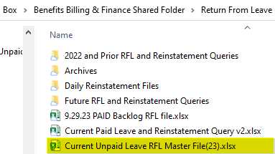
- Review Payroll Deductions by running the FIN 001 Query.
- In PeopleSoft, navigate to Main Menu > Reporting Tools > Query > Query Viewer
- In the search field, enter UC_FIN001. Save to favorites.
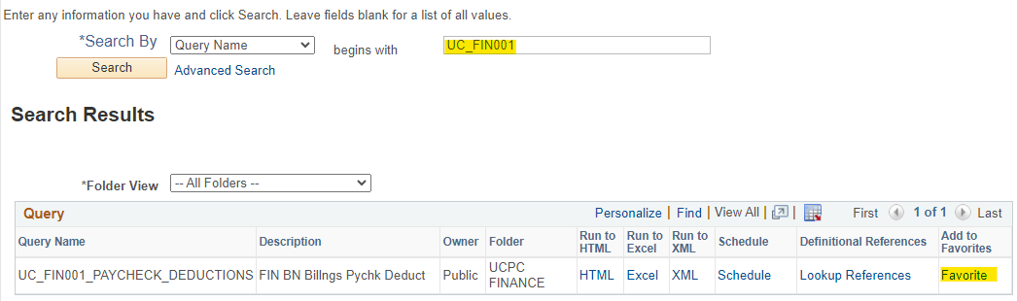
- Click on the Excel link under the heading ‘Run to Excel’.
- Enter the EMPL ID in the applicable search field.
- Report will open in Excel.
- Run ‘001_Format’ macro to format the report. This will remove unnecessary columns and highlight any anomalies that may need further research, such as arrears and refunds. It will also show the status of the paycheck.
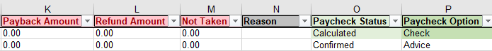
- One example of an anomaly that would need to be further investigated would be a period that has payback amounts (arrears) and was also billed in Oracle. If so, the Oracle charges should have a credit memo processed to clear the charges for the arrears deductions taken.
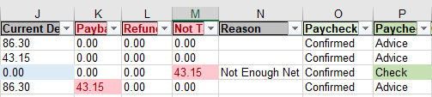
- Review Paycheck Issue Date column to determine if there are any missed paychecks. These are periods that should have been billed or need to be collected using the One-Time Deduction Sheet.
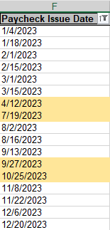

- Insert a Pivot Table to analyze the periods missed; use the criteria and group selection below.

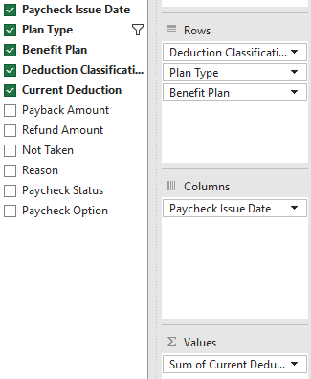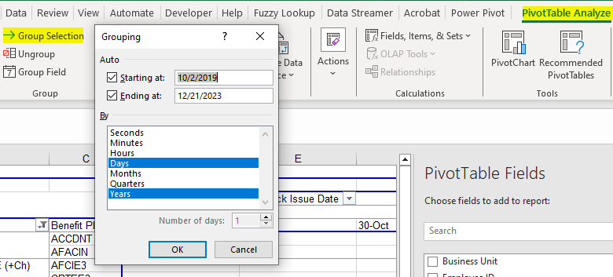

  - Copy and Paste (Values) onto new spreadsheet to be able to edit the data. Change the tab name to ‘Summary’.
  - Inset columns as placeholders for the missed paycheck dates, add in the date and highlight. The employee in this example missed deductions for ½ May, June, July & ½ August coverage.
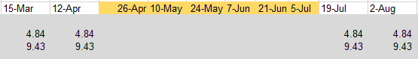
  - Fill in the missed deduction amounts for each plan and change cell style to highlight the difference between employee portion and UC contributions.

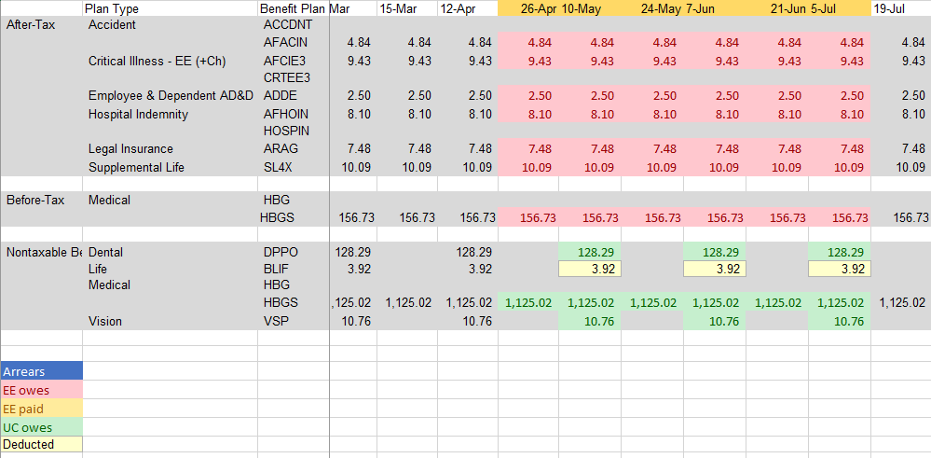

- Manually review if employee was continuously enrolled in benefits or if any plan changes took place by reviewing the benefits summary page. PeopleSoft > Main Menu > Benefits > Benefits Summary
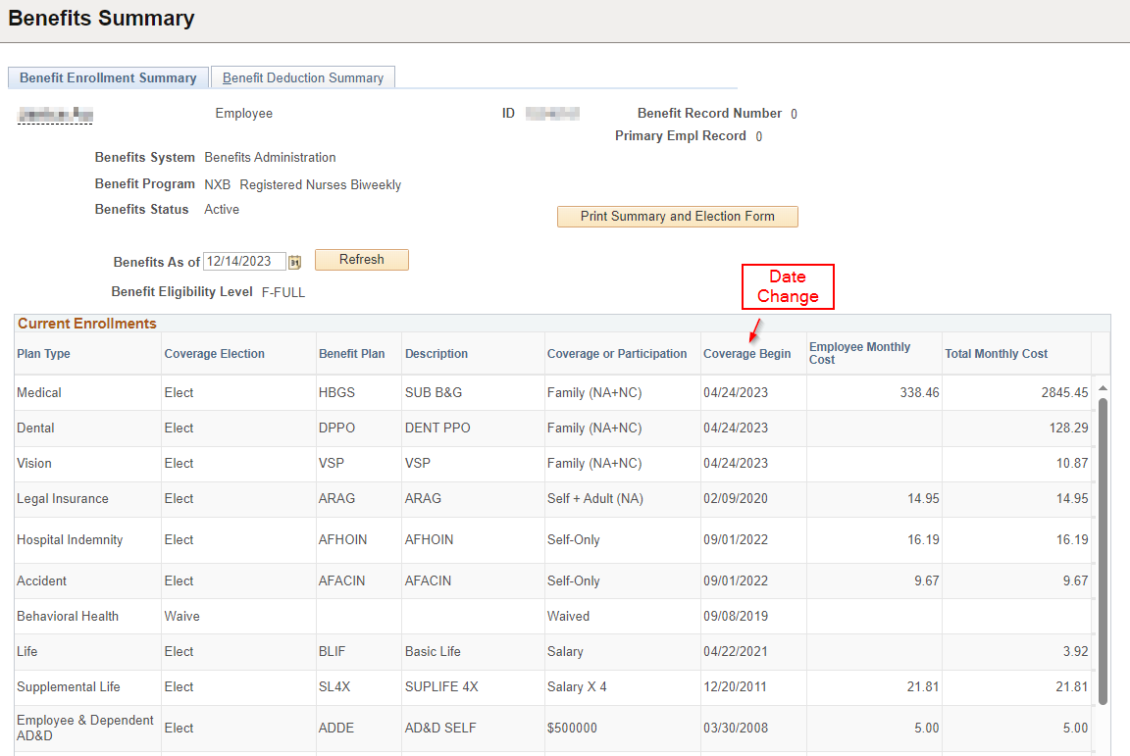

- Save the Reconciliation workbook in the Account Reconciliation folder. Using the following format
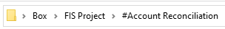

In Oracle run a ‘Transaction Register’ to summarize the benefits account.
- Go to Oracle Home screen and click on ‘Tools’ then the ‘Reports and Analytics’ icon.

- The ‘Transaction Register Report’ is called the ‘page 1’ report. The path is:
- Click on the link for ‘page 1’, enter the ‘Bill-to Customer Account Number” and click on ‘Apply’.
- Once the report is displayed, scroll to the bottom and click on the following icon to expand the report to all rows. 
- Export to CSV file using the path below:

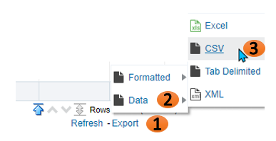

- Use ‘Transaction Register’ macro to format the report.
- Copy and paste ‘Previous Transaction Number’ column into ‘Transaction Number’ column for credit memos only. Sort Transaction Number column Smallest to largest.

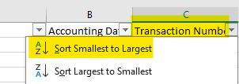

- Subtotal the data using the following criteria:
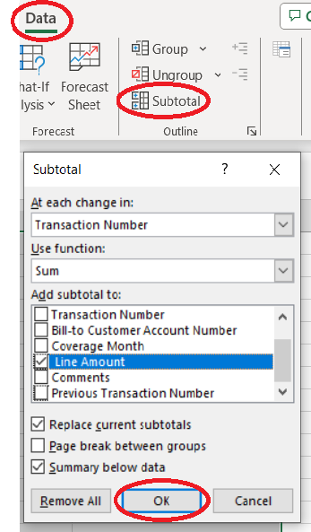
- Uncheck the box for ‘Previous Transaction Number’ under the “Add subtotal to:” field.

- Identify any adjustments that need to be made to the benefits billing account in Oracle due to the return from leave date. (total rate to employee rate or employee having/not having deductions for coverage) or change in plans.
    - Review if employee was continuously enrolled in benefits or if any plan changes took place by reviewing the benefits summary page. PeopleSoft > Main Menu > Benefits > Benefits Summary

    - Go to Job Data record in PeopleSoft to confirm RFL date.

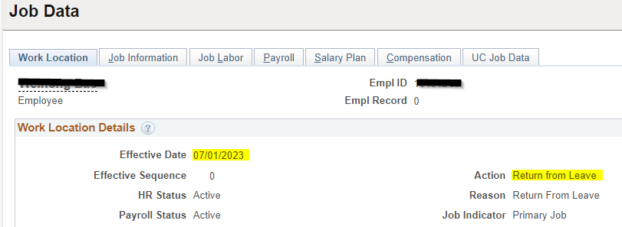

- If RFL date is 7/1/2023 they are not responsible for Total Rate for July coverage forward.
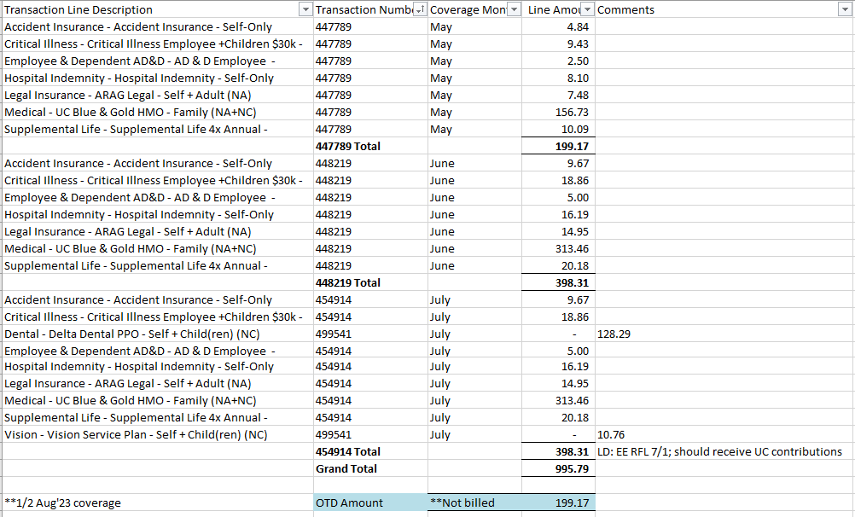

- Export any payments made on the account. In Oracle navigate to Billing > Review Customer Account Details to export payment activity to excel.
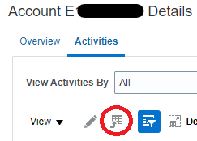

- Copy and paste the data into the workbook that has the FIN001 and rename the tab “Pmts”.
- Filter the “Class” column in the excel report to view ‘Payment’.
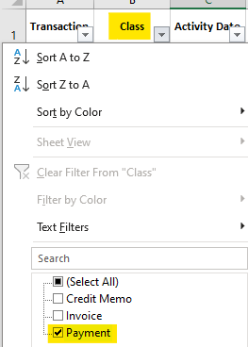

- Check “Status” to confirm there are no reversed payments. If there is a ‘reversed’ payment do not include in the payments total.
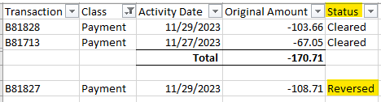

- On the Transaction Register, apply any payments to the invoices to identify the balance the employee owes or needs to be refunded. In the example below the employee made payments for all billed premiums, however, was not billed for ½ Aug’23 coverage. This will need to be added to the One-Time Deduction workbook.
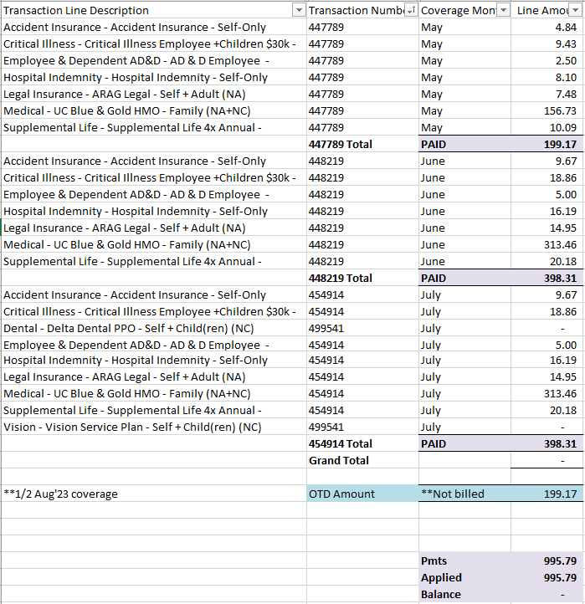
- Move the Transaction Register into the workbook that contains the FN001 and Pmts.

- Make any adjustments (Credit Memos) in Oracle for Total Rate or that have deductions taken from paychecks.
- To adjust an invoice click on the invoice line to highlight it.
- Click on the edit icon that looks like a pencil.
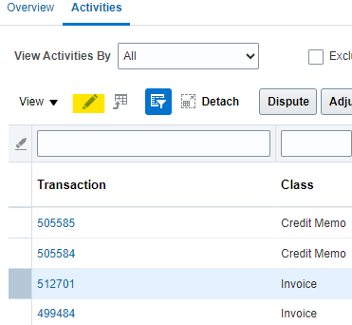
- From the Actions menu, select “Credit Transaction”.
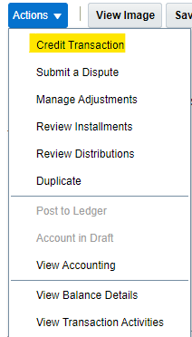

- ‘Transaction Source’ should be UCPATH MANUAL. The coverage month should be the Month and Year the invoice covers. Leave the dates as they are. Add one of the following to the comments box:
EE had deductions for coverage.
EE had deductions for 1/2 month coverage.
EE RFL x/x; should receive UC contributions.
EE RFL x/x; should have deductions for coverage.
EE RFL x/x; balance to be collected via OTD.
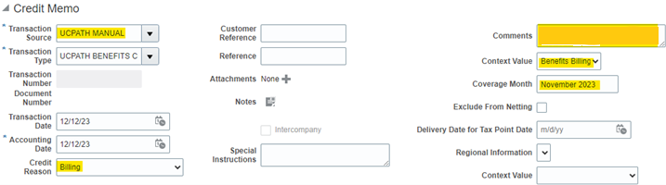
- Click credit lines and credit the relevant plans based on what was deducted via paycheck or that will be collected via paycheck.

- On the ‘Summary’ tab of the reconciliation workbook highlight the periods that were paid with the neutral cell style color to reflect payments made towards the balance due.

- Summarize what will be added to the OTD (balance due or refund) for both the employee and the UC contributions.

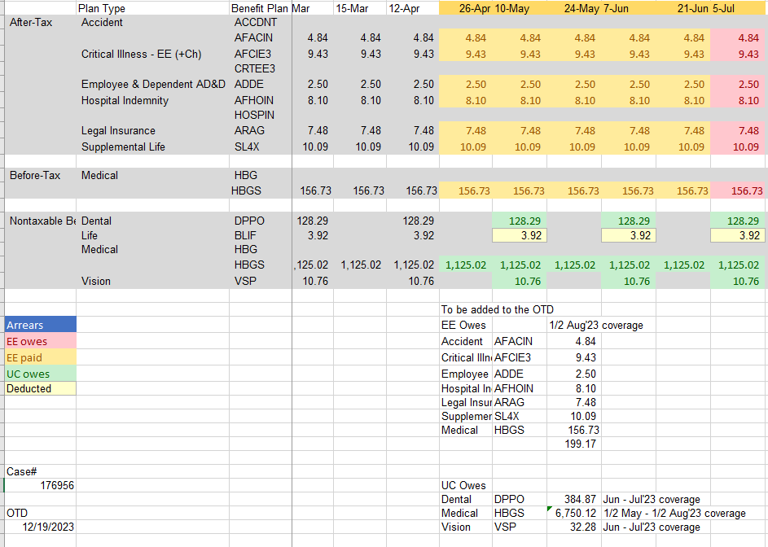

- Save the workbook in the Account Reconciliation folder.

- Update the ‘Current Unpaid Leave RFL Master File(23)’ located below.

          - Open using Excel Online through Box.
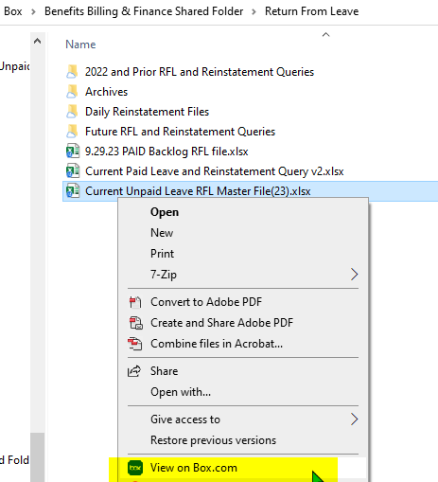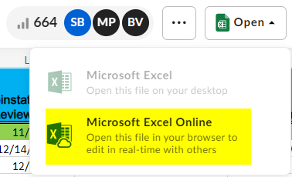

          - Once workbook is open, change to ‘Temporary’ view by clicking the icon circled below. This will allow filters to be used without effecting others.

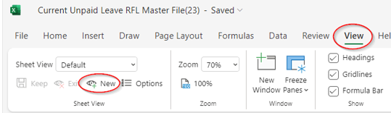

          - Locate the reconciled employee using the employee ID
          - Update columns P-S as shown below.
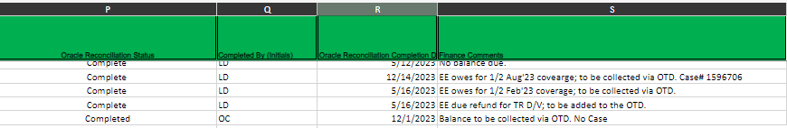

Total Average Processing Time: 30 minutes - 2 hours

List of Repetitive manual steps:

- Identify Returned Employees: Access the 'Current Unpaid Leave RFL Master File(23)' to identify employees who have returned from leave.
- Review Payroll Deductions:
  - Run the FIN 001 Query in PeopleSoft, with multiple manual steps such as navigating through PeopleSoft menus, running the query, exporting to Excel, and formatting using macros.
  - Analyze the report for anomalies, like arrears and refunds, requiring further investigation.
  - Review the paycheck issue date column to identify missed paychecks.
  - Insert a Pivot Table to analyze missed periods.
- Oracle Transaction Register:
  - In Oracle, run a 'Transaction Register', steps include navigating through Oracle menus, exporting to CSV, and using macros to format the report.
  - Copy and paste data, sort, and subtotal based on specific criteria.
- Export Payments from Oracle: Export payment activity in Oracle, including steps such as filtering data, checking payment status, and applying payments to identify the balance owed or refund.
- Highlighting in Summary Tab: Manually highlight periods that were paid on the 'Summary' tab of the reconciliation workbook.
- Salesforce Case Creation (Not in scope for automation): Open a case in Salesforce for balances over $50, including filling in required fields and adding comments summarizing actions taken.
- Email Employee (Not in scope for automation):: Email the employee using a template to notify them of the status of their Return From Leave reconciliation.
- Update One-Time Deduction (OTD) Sheet (Not in scope for automation):: Locate the relevant OTD sheet and add the required information based on the reconciliation.
- Update 'Current Unpaid Leave RFL Master File (23)': Open the file using Excel Online through Box, change to 'Temporary' view, and update specific columns based on the reconciliation.
These manual steps involve accessing multiple systems, running queries, exporting data, and performing various data manipulations, highlighting the potential for increased efficiency through automation.
Noted (9 manual steps) significant manual processes and 52 manual tasks.

Proposed Solution

Step 1.
Identify Returned Employees
From FIN284 report, business is responsible to clean and produce a list of employees where the following conditions are met:
- Not future dated i.e. paycheck issue date is not greater than today’s date
- Payroll status neither: terminated, retired, or deceased
- Elig Fld 1 flag neither ‘G’ or ‘N’
- Pay Status is not ‘Paid Leave’
- Has no completed or pending recon status based on RFL Master File that business kept for logging and tracking purpose.
- No duplicate EEID
Once FIN284 report is cleaned, the only input the bot needs is an input Excel workbook consisting of 1 worksheet with following columns:
- Business Unit
- EEID
- Payroll Status
- Pay Status
- Pay Group
- Current Date
- Action Date
- Elig Fld1
- Elig Fld2
- Empl Record
- Job Indicator
Business is responsible for dropping the input file in RPA Box folder (path: Box\RPA\{ENV}\Return From Leave Reconciliation\{ENV} File Drop)

Step 2.
AA Bot Initiation
Below are initiation steps performed by AA bot:
- Setup Runtime Directories
  - Ensure required folders (e.g., Logs, Input, Output, Exceptions, Archive, Config, Process Logs, Snapshots) exist.
  - Create them if missing and apply appropriate access controls (ACLs).
- Load Configuration
  - Read the bot configuration file (Config.json or .xml) to retrieve paths, credential keys, logging level, and email distribution lists.
- Clean Up Residual Applications
  - Terminate or close leftover instances of applications like Excel, PeopleSoft browser sessions, and Box drive.
- Initialize Logging
  - Set up Action and Exception logs with headers.
  - Generate a unique run ID (UUID) and log the “Bot Start” event

Step 3.
AA Bot Downloading Input File into EC2 and Reading Into Main Data Table.
Inside EC2 server, Bot will download the input file dropped in RPA Box folder (path:Box\RPA\{ENV}\Return From Leave Reconciliation\{ENV} File Drop) from AA control room utilizing AA Box package (API). Credentials required to establish authentication are stored within config.json inside AA control room – RFL folder and credential stored in AA control room locker.

The downloaded input file (Excel) will be temporarily stored in EC2 directory: C:/ProgramData/AutomationAnywhere/Bots/Logs/RFL-UCPath/Input

The purpose of downloading the input file into EC2 directory is for bot to read the data utilizing AA Excel Basic action and stores into data table (or refer to as main data table).

Step 4.
Identify Returned Employees by Payroll Status, Job Indicator, and Arrear Balance. Ready for Reconciliation.
Job Data check
Bot initiates a login to Peoplesoft and navigate to Job Data page. Once login is established and arrive at Job Data page. Bot iterates the list of EEID from main data table and as it lands on Job Data page, it reads and captures the following data points:
- Payroll Status – in Work Location tab
- Job Indicator – in Work Location tab
- Pay Group – in Payroll tab (NOTE: pay group is to indicate whether EE is monthly or biweekly employee)

Rules for Exception
As a process of determining reconciliation, any EEID with the following conditions will be removed from main data table and place in exception data table:
- Payroll Status is not Active
- Job Indicator is not Primary Job
Change note as of 4/13/2026 (based on UCP-188100) : all EEID with Job Indicator equals Primary Job, regardless of Payroll Status will advance to the next processing. Therefore the rules for exception is changed to include all Payroll Status.

All EEID with above conditions are placed in exception data table with exception status :”Payroll Status or Job Indicator did not meet criteria”
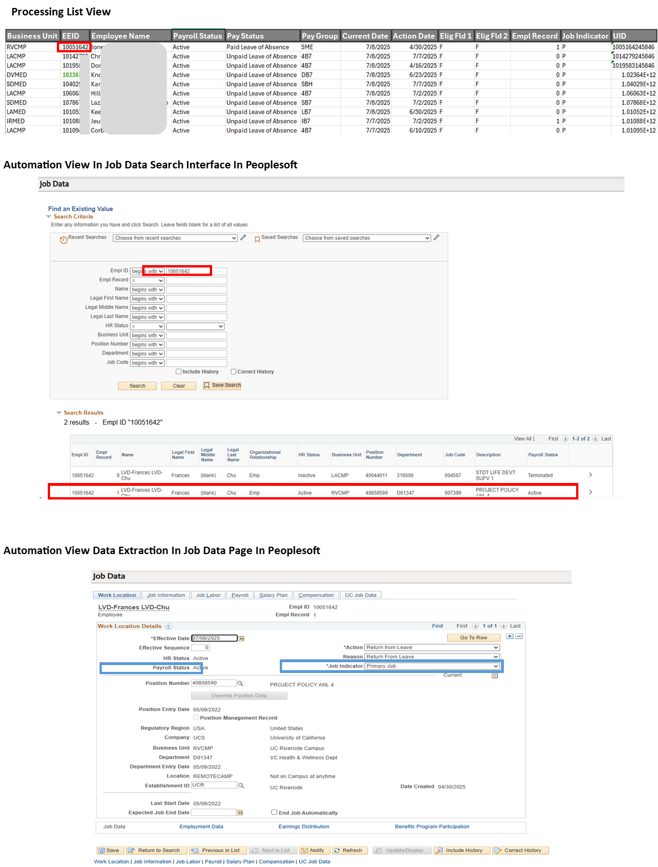
Arrear Balance check
Bot then navigates to Arrears page, and as bot iterates the list of remaining EEID in main data table, bot checks for UCS arrears records.
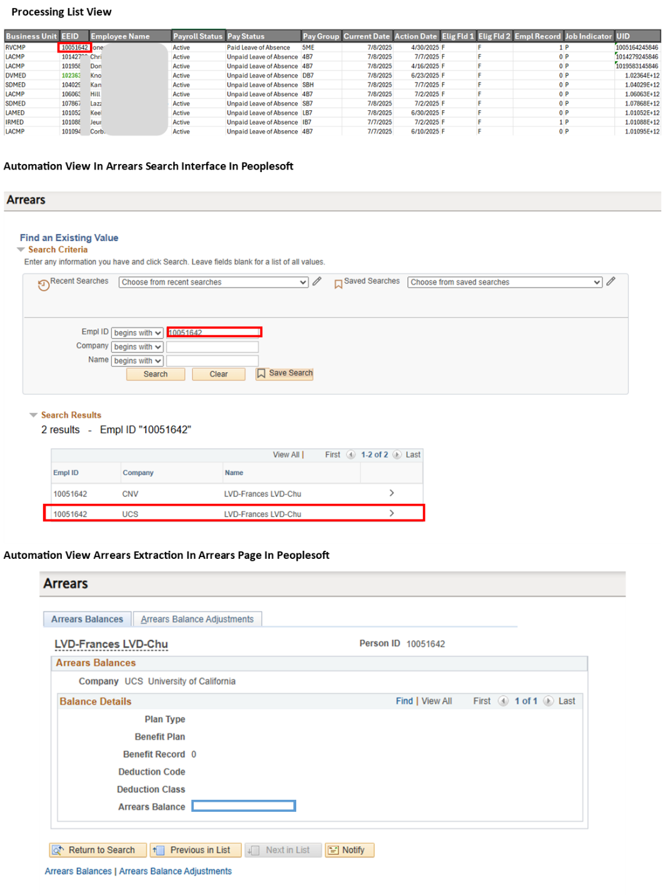
Rules for Exception
As a process of determining reconciliation, any EEID with arrear balance > $0 will be removed from main data table and place in exception data table. Exception status should be: “arrears detected”.

Change note as of 4/13/2026 (based on UCP-188100) : All accounts regardless of arrear balance will advance to the next processing, therefore arrear balance will not be filtered. Task bot RFL-3-CheckArrears will be disabled.

The main data table now consists of recon-eligible EEID.

Step 5.
Review Payroll Deductions
Bot then navigates to Query Viewer page; search for FIN001 query viewer. As bot iterates the list of remaining EEID in main data table, bot downloads FIN001 report (in .xls) into EC2 repository: C:/ProgramData/AutomationAnywhere/Bots/Logs/RFL-UCPath/Input/FIN001

Payroll Monthly and Biweekly Calendars
Payroll Monthly and Biweekly calendars are essential sources for identifying possible missed paychecks within FIN001 reports. These calendars are hosted in the following Box folder : Box\#UCPC-FN-BB\#PII-UCPC-FN-BB\Return From Leave\RPA Recon\Resource Documents

For one time only, bot will download the payroll calendar hosted above from AA control room utilizing AA Box package (API). The calendar will be stored inside UCPATH > Utilities folder within AA control room. Credentials required to establish authentication are stored within config.json inside AA control room – RFL folder and credential stored in AA control room locker.

Dataframe Initiation, Missing Dates Identification, Inserting Missed Paychecks
Once bot finishes downloading FIN001 for all EEID, bot triggers Python script to perform the following data processing:
- Read payroll calendar into payroll dataframe
- Read FIN001 sheet into FIN001 dataframe
- Identify missing paycheck issue dates by comparing dates on FIN001 and payroll dataframe per selected plan types below:
  - Legal Insurance
  - Supplemental Life
  - Employee & Dependent AD&D
  - Basic Dependent Life
  - Exp Dependent Life - Spouse/DP
  - Exp Dependent Life - Child
  - Voluntary Long-Term Disability
  - Voluntary Short-Term Disability
  - Accident
  - Critical Illness EE
  - Critical Illness SP
  - Hospital Indemnity
  - Dental *
  - Vision *
  - Life *
  - Basic Disability *
* for bi-weekly these plan types are deducted in monthly basis
- Inserting missed paychecks as identified by missing paycheck issue dates (step 3 above) given the selected plan types above. Highlight the inserted missed paycheck by setting cell’s color.
- Identify variances in current deduction for each selected plan types above in month-to-month basis and highlight by changing cell’s color.

Rules for Exception
If at any time either of following condition is met, the script processing of FIN001 report should stop:
- If more than 1 pay groups identified. Exception status should be: “multiple pay groups identified”.
- If there is no missed paychecks on selected plan types identified. Exception status should be:”no missed paychecks”
Bot skips to the next EEID and log the EEID to exception table.

Change note as of 2/19/2026 (based on UCP-184825) : Label update on scenario where within FIN001 1) the employee does not have a record of having any in-scope plan -or- 2) there is no missed paycheck dates identified. The label for scenario 1 is “No In-Scope Plan Type”; the label for scenario 2 is “No Missed Paycheck Date”

At this point, FIN001 dataframe should consist of identified missed paychecks, variances for selected plan types.
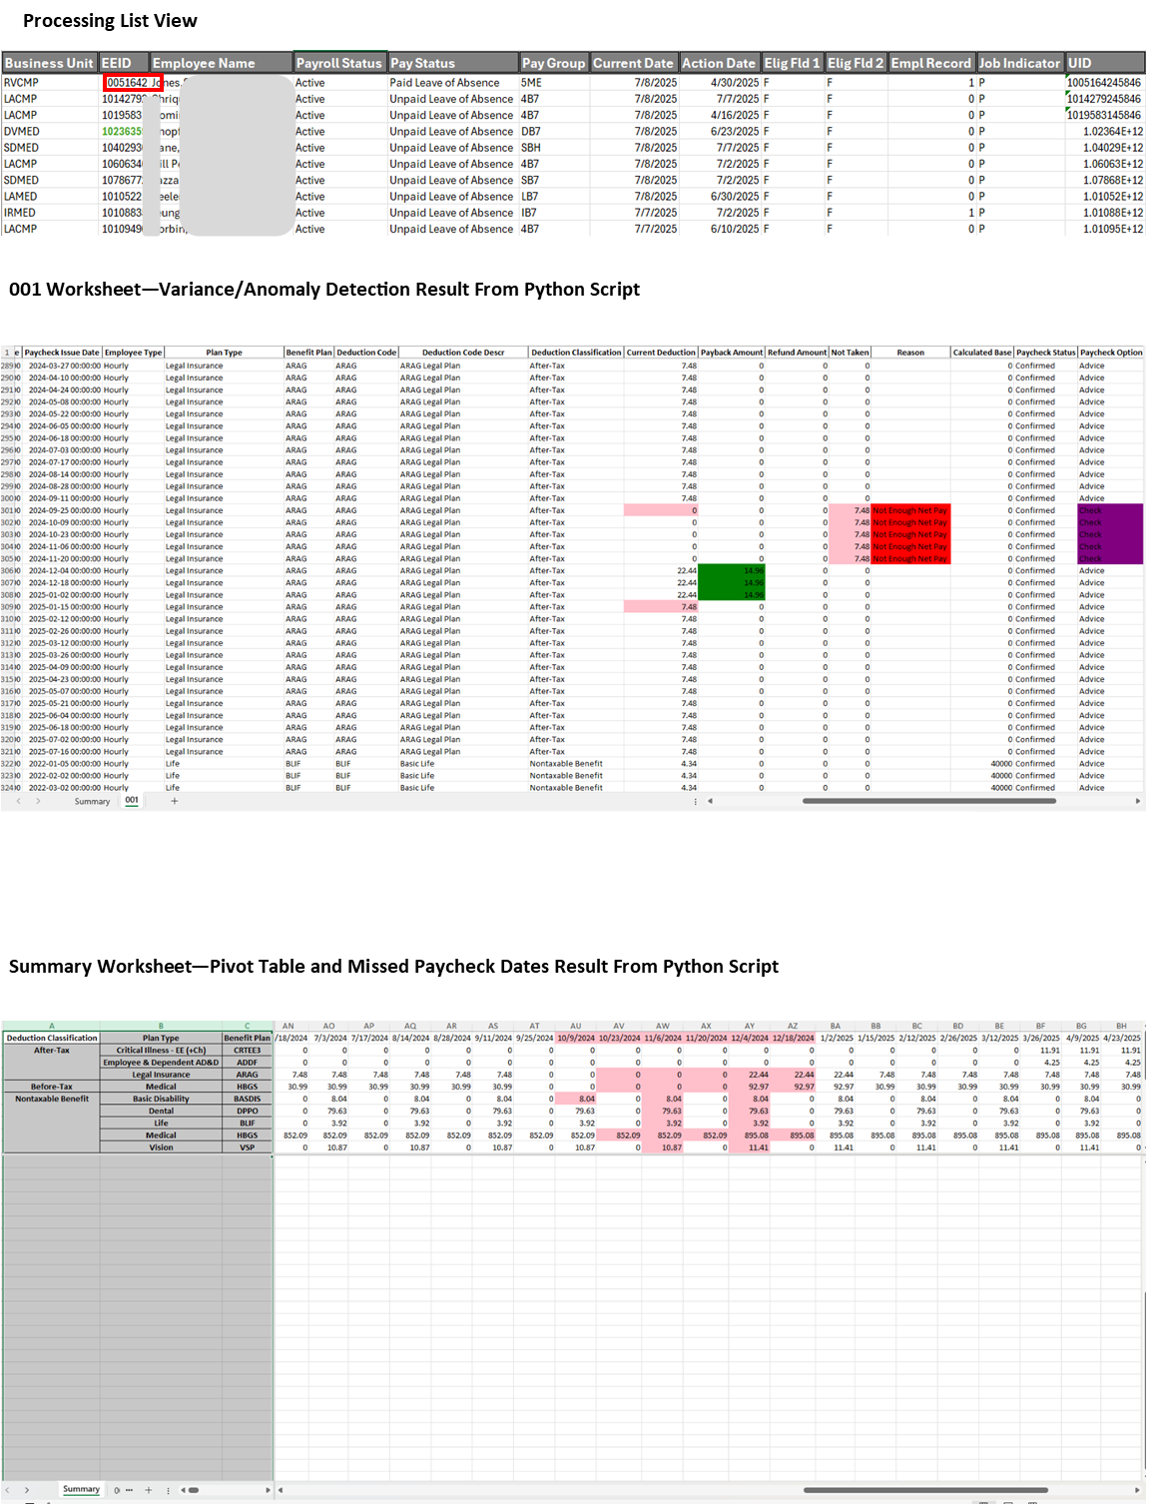

Step 6.
Oracle Transaction Register
Bot initiates a login to Oracle Cloud Financial (url: https://elda.fa.us2.oraclecloud.com/) and navigate to Page 1 page. Path: Oracle Cloud Financial > Home > Tools > Reports and Analytics > page 1 . In page 1 page, bot inserts the EEID prefixed with ‘e’, for example: e10012345, into Bill-to-Customer Account field and extract the transaction register analysis report (in csv). Note: Steps are described in Current Process section above

The transaction register analysis report will be processed under Python script as follows:
- Read transaction register analysis report into transaction register dataframe
- Format transaction register dataframe following business rules.
- Append transaction register dataframe into the cluster of dataframes that include FIN001 dataframe

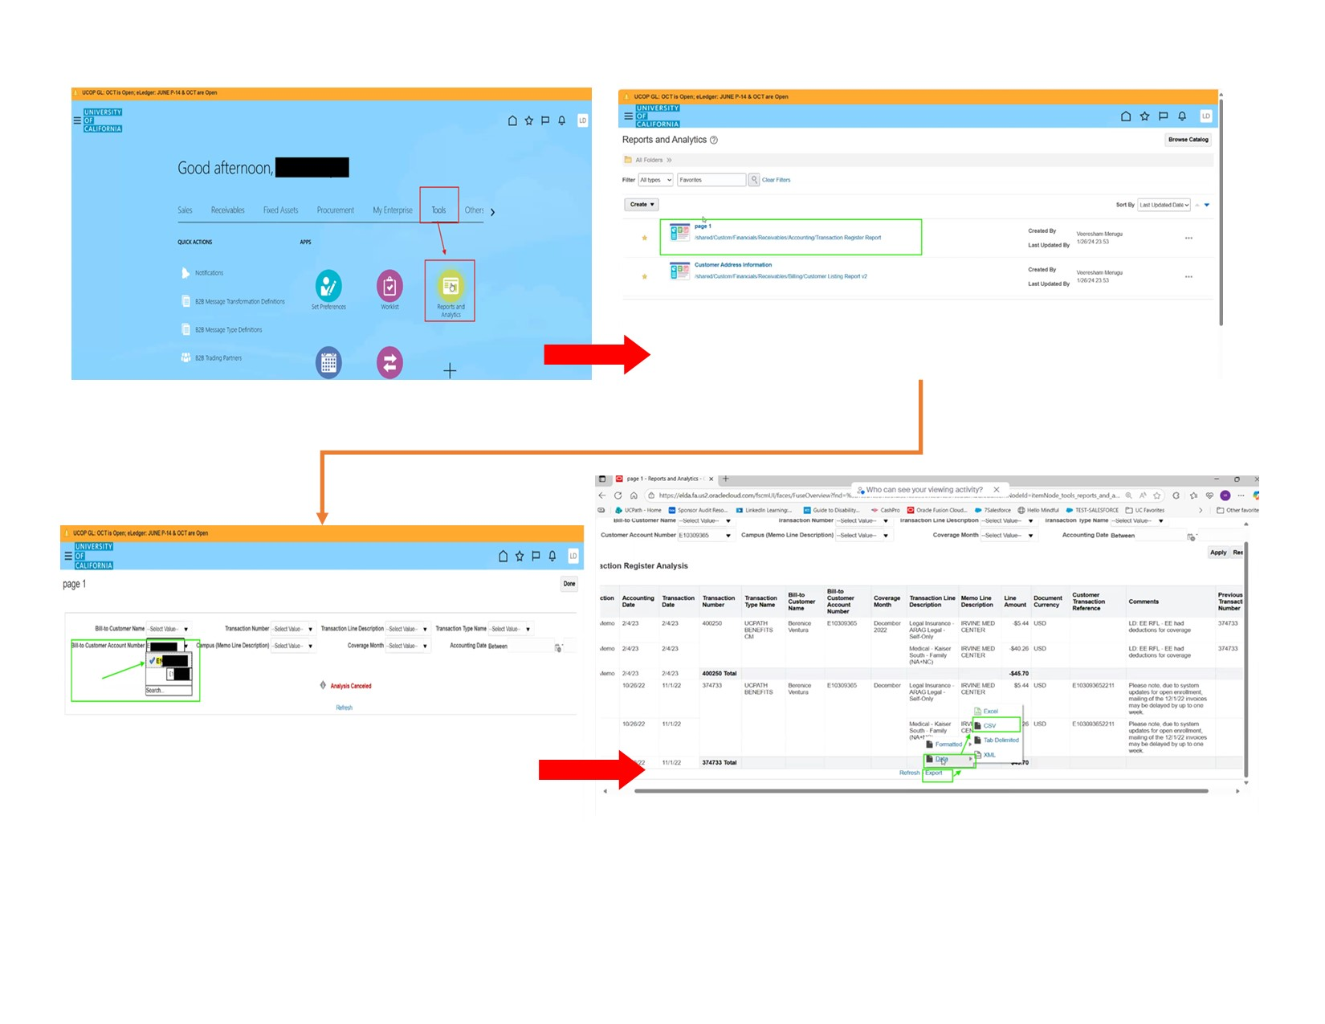

Step 7.
Export Payments from Oracle
Bot then navigates to Oracle Financials > Home Screen > Receivables > Billing > Review Customer Account Details. Bot inserts the EEID prefixed with ‘e’, for example: e10012345, into Customer Number field and extract the payment report. Note: Steps are described in Current Process section above

The payment report will be processed under Python script as follows:
- Read payment report into payment dataframe
- Format payment dataframe following business rules.
- Append payment dataframe into the cluster of dataframes that include FIN001 dataframe

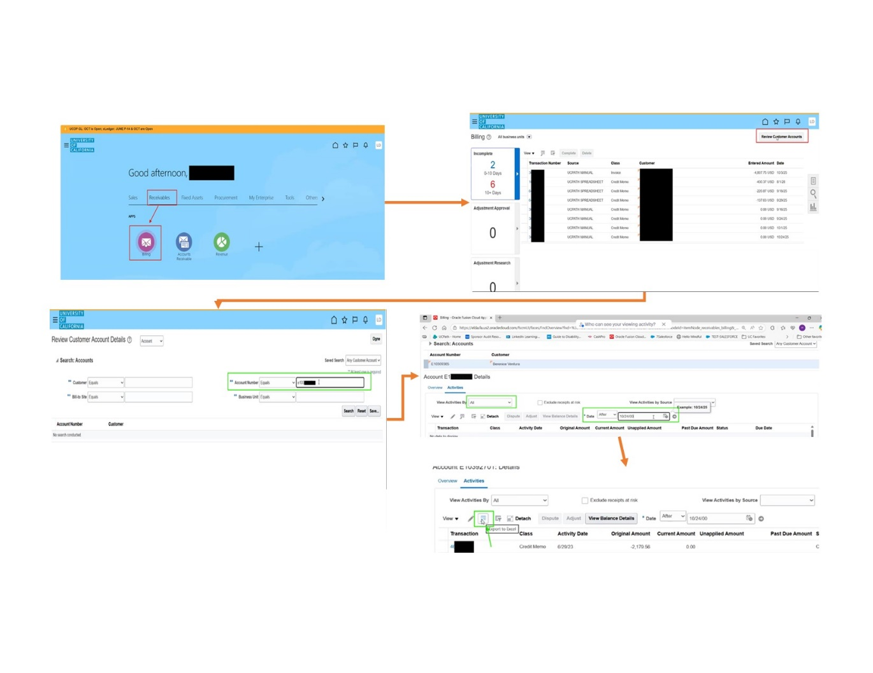

Step 8.
Data Processing of Payroll Deduction (FIN001) Report
At this step we have the following dataframes:
- FIN001
- Transaction Register
- Payment
Finally, Python script will perform a pivot table conversion on FIN001 dataframe and instantiate Summary dataframe.
All dataframes will then be compiled into individual worksheet under the final Excel report.
- FIN001 – will be FIN001 worksheet under final Excel report
- Transaction Register – will be Transaction Register worksheet under final Excel report
- Payment - will be payment worksheet under final Excel report
- Summary - will be Summary worksheet under final Excel report

Step 9.
Output
Upon completion of bot run, bot is going to perform the following:
- Migrate logs, final reports (Excel), input file, and artifacts from EC2 directory to the respective RPA Box folders utilizing Box API.
- Send email confirmation to business with summary of the run.

Glossary Terms (RFL)

Term | Definition
AA | Automation Anywhere
Exception data table | Data table consisted of EEID that does not meet the criteria for reconciliation candidacy. This data table is used to capture any business or system error impacting each EEID during bot run.
Main data table | Data table that reads from Input workbook supplied by business. This data table is used as the main reference for the bot as it checks for multiple status and downloads FIN001 report for each employee in the list.
Query Viewer | A tool in UCPath used to view and run queries to retrieve specific data.

Workflow diagram

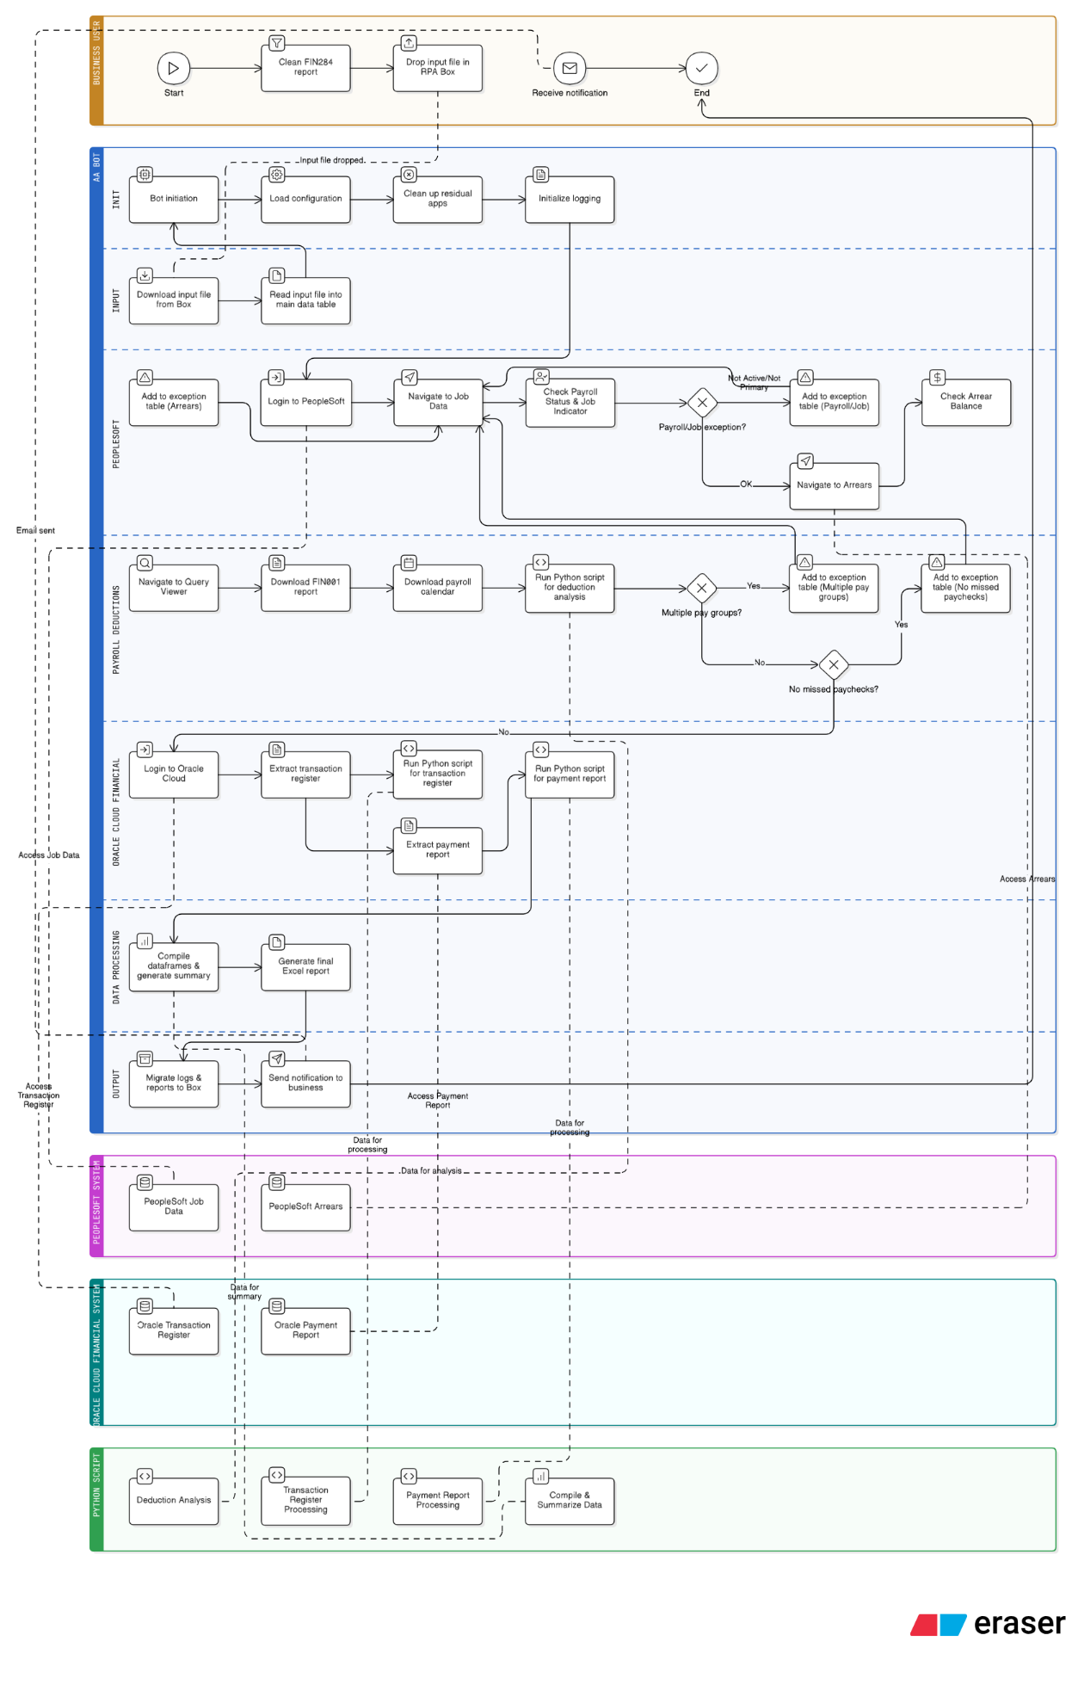

Technical Change Note
      - Changes per UCP-184825
No | Item | Change Description | Reason/Justification
1.0 | ReturnFromLeave-FinalReport.py | Line 262:  # as of 02/3/2026, this line is moved up. dfOrigin is the original dataframe  dfOrigin = df  Line 264:  # as of 02/3/2026 add column 'is new row' to df and set to np.nan (blank)  df['Is New Row']= np.nan  Line 269 - 270:  # as of 02/4/2026 check dfSelected to see if there is/are rows where plan type is in selectedPlans  if len(dfSelected) ==0:  return "No In-Scope Plan Type"  Line 291 - 292:  # as of 02/4/2026 add If ~df['Is New Row'].any() which will return True if there is no value in that column that is true. np.nan is ignored in this boolean  if ~ df['Is New Row'].any():  return"No Missed Paycheck Date"
2.0 | RFL-5- DataProcessFin001 task bot | Added lines 28 - 35 to handle the scenario 1 i.e. when FIN001 does not contain in-scope plan type
2.1 |  | Added lines 36- 42 to handle scenario 2 i.e. when FIN001 contains any selected plan type(s) however there is no missed paycheck date identified.

      - Changes per UCP-188100
No | Task Bot Name | Change Description (what has been changed) | Reason/ Justification
1.0 | RFL-3-CheckArrears | Line 16 - remove “string $rTableRow2[13]$ Not Equal to Active” on IF statement | $rTableRow2[13]$ refers to Payroll Status read from Job Data. Since all Payroll Status should be included this condition is no longer needed.
1.1 |  | Disable all Steps | All actions in task bot are disabled and not deleted. Disabling the actions gives us an option to enable them again in the future.
1.2 |  | (Secondary change) Line 189 – 190: Change the filename TestTInputDataTable-checkedArrears_$sDateTime$.csv to List_of_Recon_Ready_EEID_$sDateTime$.csv | List_of_Recon_Ready_EEID (csv) file contains the list of EEID filtered on Job Indicator, Payroll Status, and Arrears. This is the list of EEID that advance to the next steps which include: FIN001 report extraction and formatting, OCF payment and TRA report extraction and formatting. The previous file name is ambiguous and is confusing.
1.3 |  | (Secondary change) Line 191 – 192: Change the filename OutputTestTInputDataTable-Exception_$sDateTime$.csv to Exception_$sDateTime$.csv | Exception (csv) file contains the list of excluded EEID and the read Job Indicator, Payroll Status from Job Data and Arrears. These EEIDs are excluded from advancing to the next steps. The previous file name is confusing and is ambiguous.
2.0 | RFL-2-ProcessTransaction | Line 95 - 129 - Added Step 2 - Screen Payroll Status and Job Data in tInputTable data table | In this step, the bot iterates through tInputTable and checks Job Indicator should be “Primary Job”. Rows that do not satisfy the condition are placed in tExceptionTable data table
2.1 |  | Line 130 - 134 - Added Step 3 - Close all browser and write to CSV | In this step, the bot closes all browser and write both tInputTable and tExceptionTable to List_of_Recon_Ready_EEID (csv) file and Exception (csv) file
2.2 |  | Line 54 – updated and added condition “… and ( “BUTTON” in window $Browser3$ does not exist )” in If condition | Adding this condition will account for the case where Job Indicator is not Primary Job and when the is no more Job Data record in the list.
3.0 | RFL-6A-OCF-TRA | (Secondary change) Line 45 - 48 - added click Reset > Clear All | Bot to click Reset > Clear All at the start of every iteration in order to clear any residual value from previous iteration.
3.1 |  | (Secondary change) Line 79 - Uncheck resize window when clicking Save button in file dialog | this is done so that the bot can find the Save button in file dialog
3.2 |  | (Secondary change) Line 99 - Add Browser: Close Tab inside Error handler: Catch | this is to close the browser tab if bot encounters an error during saving of the file
4.0 | 1.0_Main | Line 22 - disable Task Bot : Run RFL-3-CheckArrears | RFL-3-CheckArrears task bot is temporarily disabled therefore there is no need to run it
4.1 |  | (Secondary change) Line 23 - Add Task Bot: Run Utils_Chrome_Clear_Browser_BAT_script | this is to clear browser cache during the run

      - Changes per UCP-188507
No | Task Bot Name | Change Description (what has been changed) | Reason/ Justification
1.0 | Config-RFL.json | Add RPA-BusinessSupportTeam@ucop.edu on Prod node > ExceptionReportEmailTo and OutputReportEmailTo | RPA-BusinessSupportTeam@ucop.edu is requested to be added as email recipient of all email notifications from AA CR.

Appendix

